Objective

To design a proportional controller for a given digital transfer function using discrete root-locus analysis and determine the controller gain required to satisfy the specified closed-loop performance requirements.

The required performance specifications are:

𝑀𝑝 ≤ 5%
𝑇𝑠 ≤ 9𝑠
The effect of sampling time on the digital system and on the required proportional controller gain is also studied by repeating the controller design for sampling times ranging from 0.1s to 1s, in steps of 0.1s.

Theory
In a feedback control system, the closed-loop poles determine the transient characteristics of the system. The root-locus technique provides a graphical method for studying the movement of the closed-loop poles as the controller gain is varied.
For the present experiment, the system is represented in the discrete 𝑧-domain. With a proportional controller,
𝐶(𝑧) = 𝐾𝑝,

and unity negative feedback, the open-loop transfer function becomes

𝐺𝑂𝐿(𝑧) = 𝐾𝑝𝐺(𝑧)

The closed-loop transfer function is therefore
𝑝

𝑇𝐶𝐿
𝐾𝑝𝐺(𝑧) (𝑧) = 1 + 𝐾 𝐺(𝑧)

The corresponding characteristic equation is

1 + 𝐾𝑝𝐺(𝑧) = 0.

As 𝐾𝑝 varies, the roots of this characteristic equation move in the 𝑧-plane, forming the discrete root locus.
For a digital system, the relation between the continuous 𝑠-plane and discrete 𝑧-plane is

𝑧 = 𝑒^{𝑠𝑇},

Where T is the sampling time. If
𝑠 = 𝜎 + 𝑗𝜔,

then

𝑧 = 𝑒𝜎𝑇𝑒𝑗𝜔𝑇.

Hence,

∣ 𝑧 ∣= 𝑒^{𝜎𝑇}

and

∠𝑧 = 𝜔𝑇.

Thus, unlike the continuous 𝑠-plane, the interpretation of pole locations in the 𝑧-plane depends on the sampling time. The stable region of a discrete-time system is the interior of the unit circle.
The zgrid function is therefore useful for interpreting the root locus in terms of damping ratio and frequency-related specifications.

Experimental Observations and Results

GIVEN DIGITAL TRANSFER FUNCTION

For a sampling time of

𝑇 = 1 𝑠,

the given digital transfer function is

𝐺(𝑧) = | 0.32(𝑧 + 0.62)
𝐺(𝑧) = | 𝑧² − 1.15𝑧 + 0.15

The system was defined in MATLAB as:

z = tf('z', 1);
Gz_1 = 0.32*(z + 0.62)/((z - 1)*(z - 0.15));

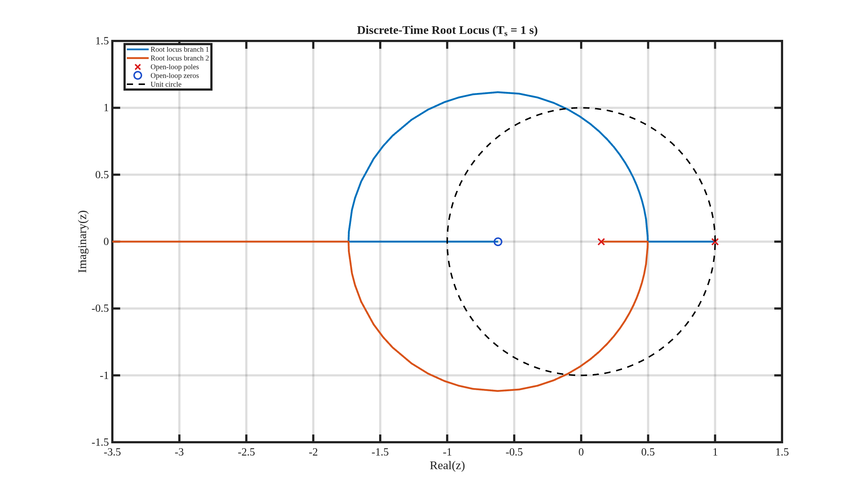

CONTINUOUS-TIME EQUIVALENT OF THE PLANT

The given digital transfer function is converted to an equivalent continuous-time transfer function using a zero-order hold:

The MATLAB result is

𝐺(𝑠) = | −0.03711𝑠 + 1.157
𝐺(𝑠) = | 𝑠² + 1.897𝑠

The poles of the continuous equivalent system are

𝑠 = 0, 𝑠 = −1.897

and the zero is

𝑠 = 31.18.

The required damping ratio is

𝜁req=0.6901
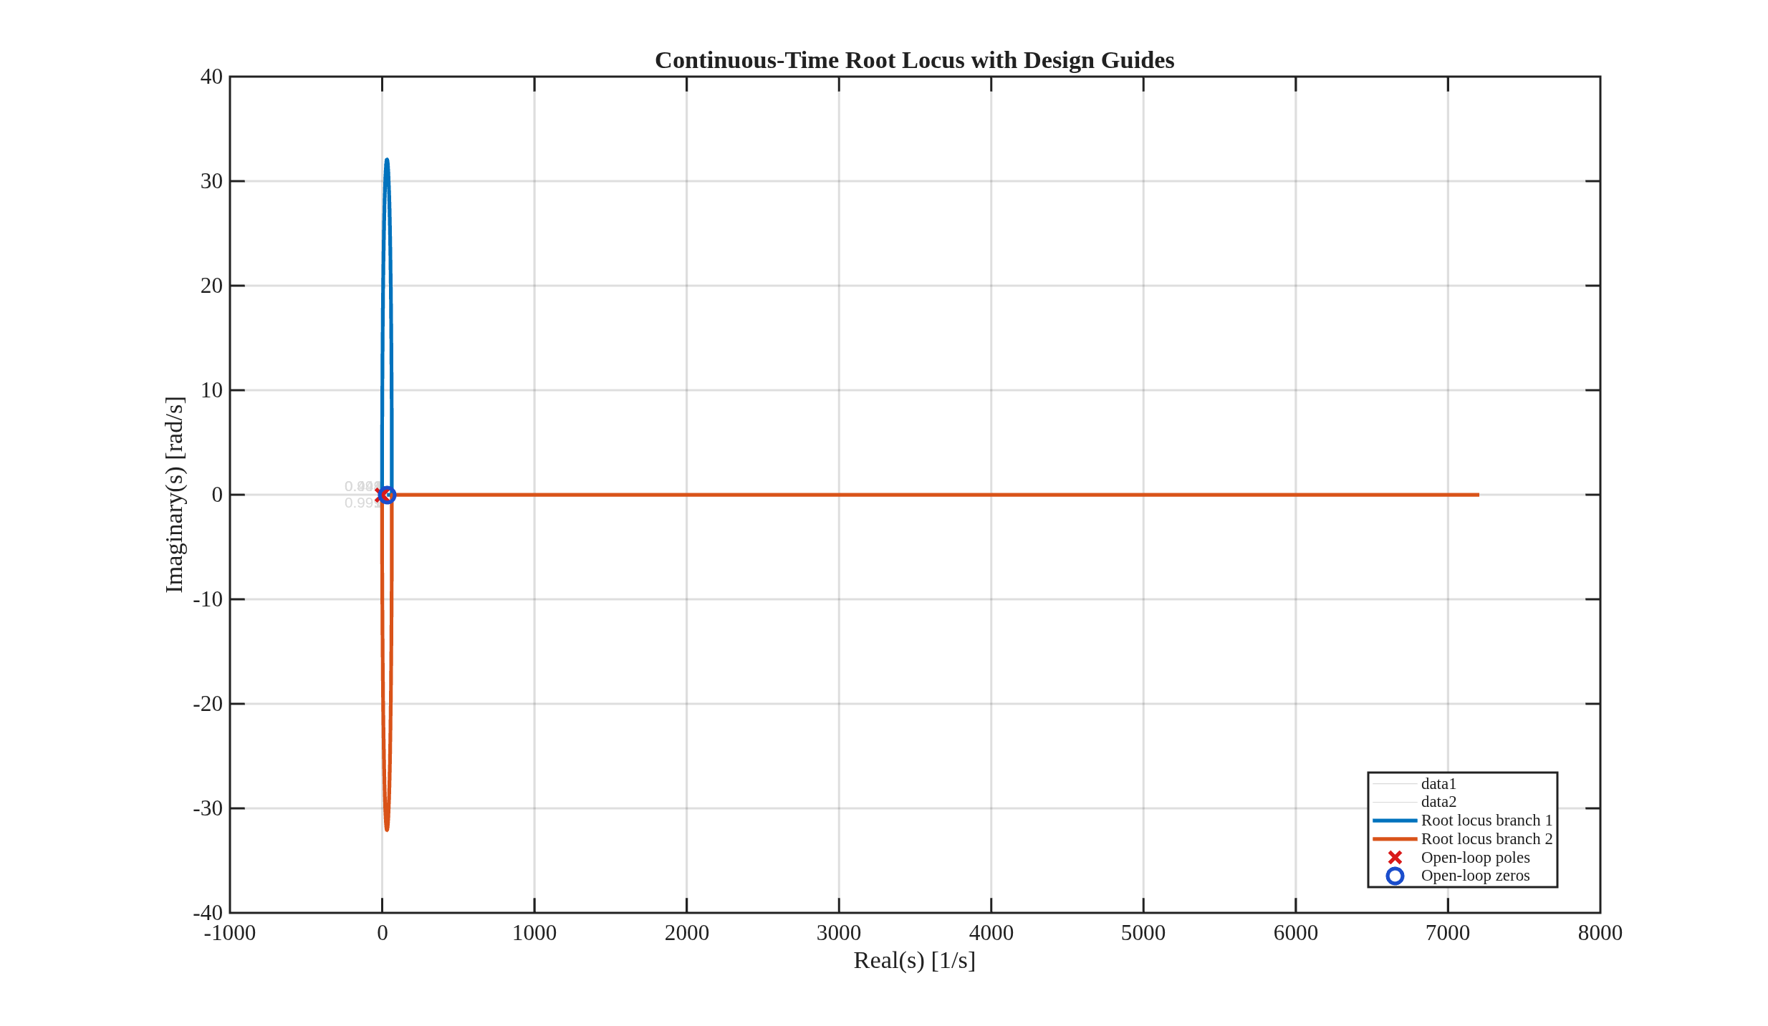

Using MATLAB stepinfo with the 2% settling-time criterion and requiring 𝑇𝑠 < 9 gives approximately

Kp,min ≈ 0.678

Kp,max ≈ 1.845

DISCRETIZATION FOR DIFFERENT SAMPLING TIMES

To study the effect of sampling time, the continuous plant is discretized using a zero-order hold for each sampling time:
𝑇 = 0.1,0.2,0.3, … ,1.0 𝑠

The corresponding digital model is obtained from
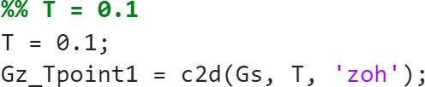

Thus, a different digital transfer function is obtained for each sampling time. The resulting transfer functions are summarized below.
Table 1. Sampling time versus discrete-time plant
Sampling time, T_{s} (s) | Discrete-time plant, G_{d}(z)
0.1 | $$\frac{0.0020559z+0.008483}{z^{2}-1.8272z+0.8272}$$
0.2 | $$\frac{0.014296z+0.024218}{z^{2}-1.6843z+0.68426}$$
0.3 | $$\frac{0.034959z+0.044445}{z^{2}-1.566z+0.56601}$$
0.4 | $$\frac{0.062591z+0.067142}{z^{2}-1.4682z+0.46821}$$
0.5 | $$\frac{0.095987z+0.090851}{z^{2}-1.3873z+0.3873}$$
0.6 | $$\frac{0.13415z+0.11455}{z^{2}-1.3204z+0.32037}$$
0.7 | $$\frac{0.17626z+0.13752}{z^{2}-1.265z+0.26501}$$
0.8 | $$\frac{0.22163z+0.15932}{z^{2}-1.2192z+0.21922}$$
0.9 | $$\frac{0.2697z+0.17966}{z^{2}-1.1813z+0.18134}$$
1.0 | $$\frac{0.32z+0.1984}{z^{2}-1.15z+0.15}$$

DISCRETE ROOT-LOCUS ANALYSIS

For each sampling time, the root locus of the corresponding digital plant is obtained by varying
𝐾𝑝.

The open-loop transfer function is

𝐺𝑂𝐿(𝑧) = 𝐾𝑝𝐺(𝑧, 𝑇)

and the closed-loop transfer function is

.
$Type an equation here.$

The root locus represents the possible locations of the closed-loop poles as 𝐾𝑝varies. The unit circle in the 𝑧-plane represents the stability boundary.

Root Locus for 𝑻 = 𝟎. 𝟏 𝒔
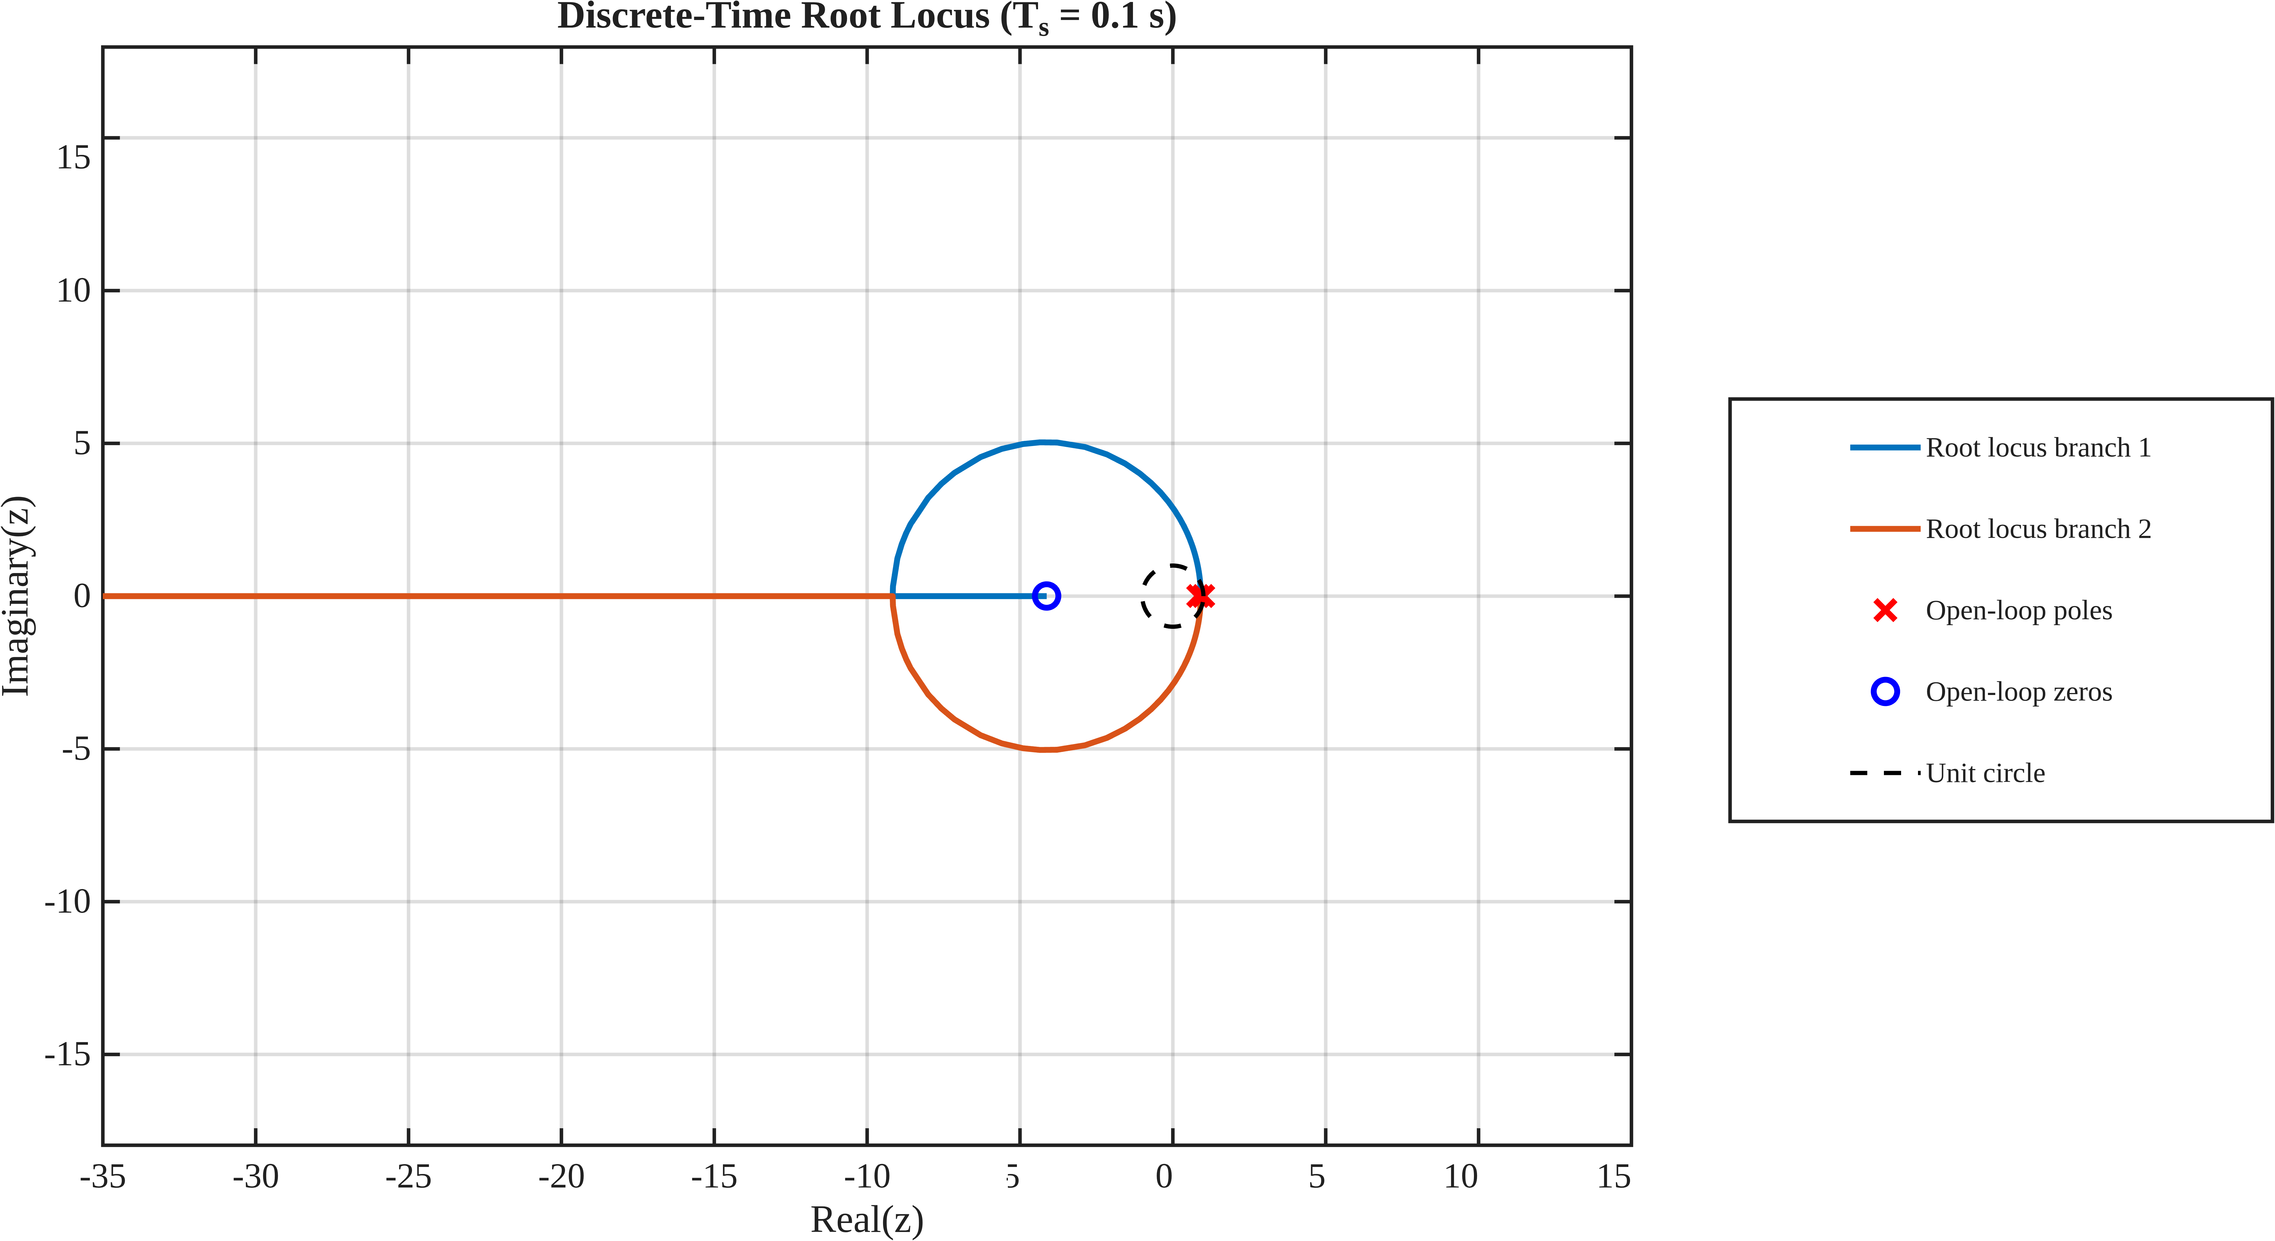

Root Locus for 𝑻 = 𝟎. 𝟐 𝒔
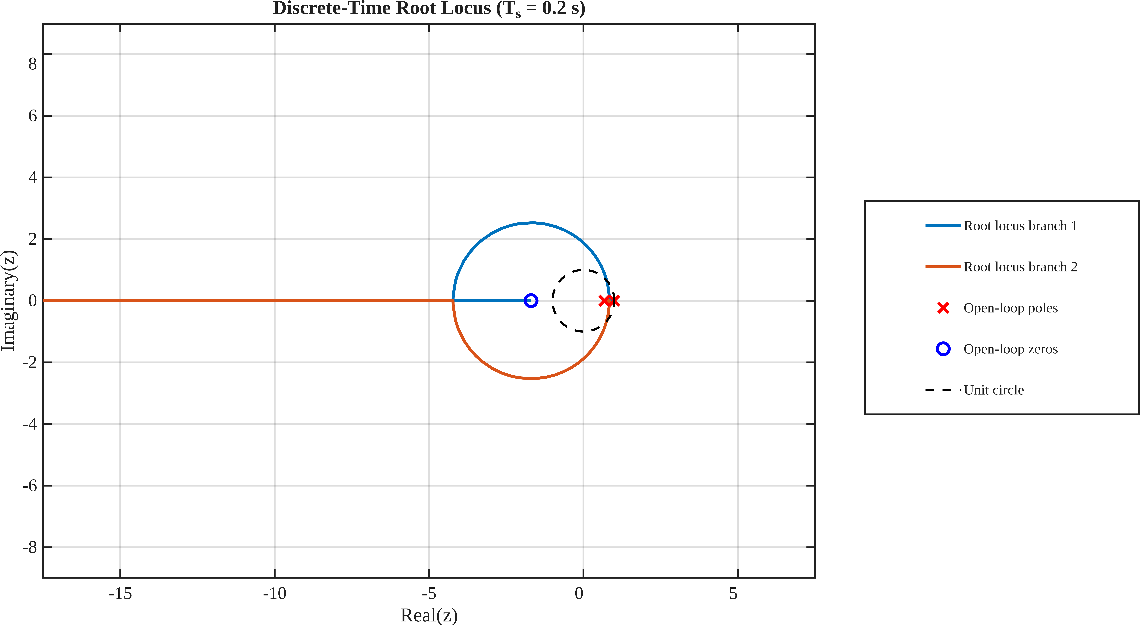

Root Locus for 𝑻 = 𝟎. 𝟑 𝒔

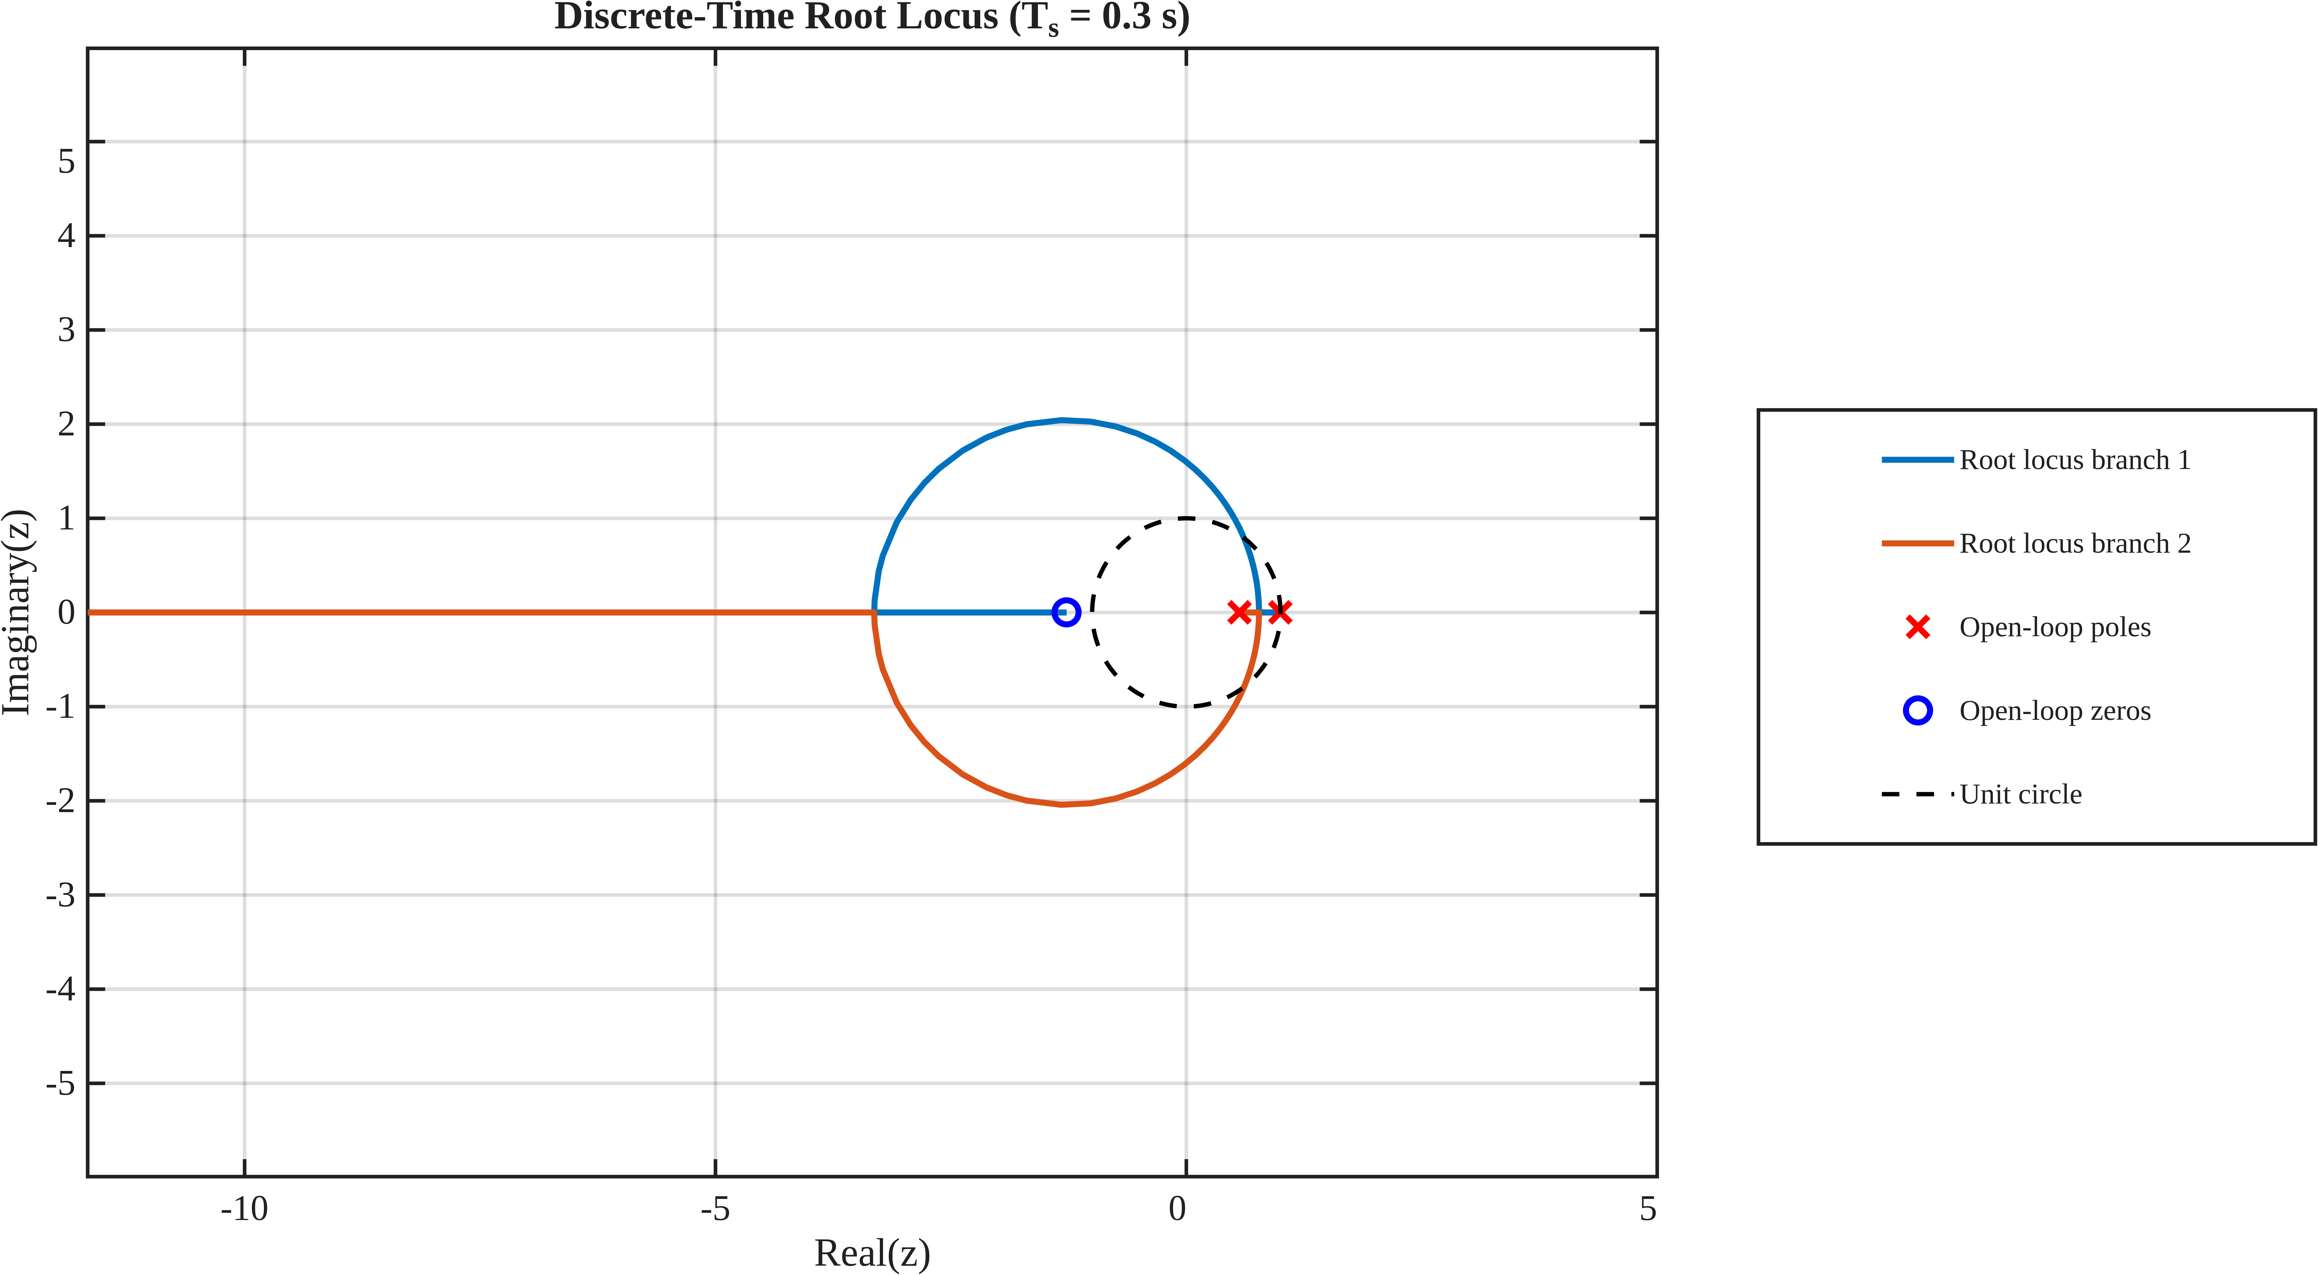
Root Locus for 𝑻 = 𝟎. 𝟒 𝒔
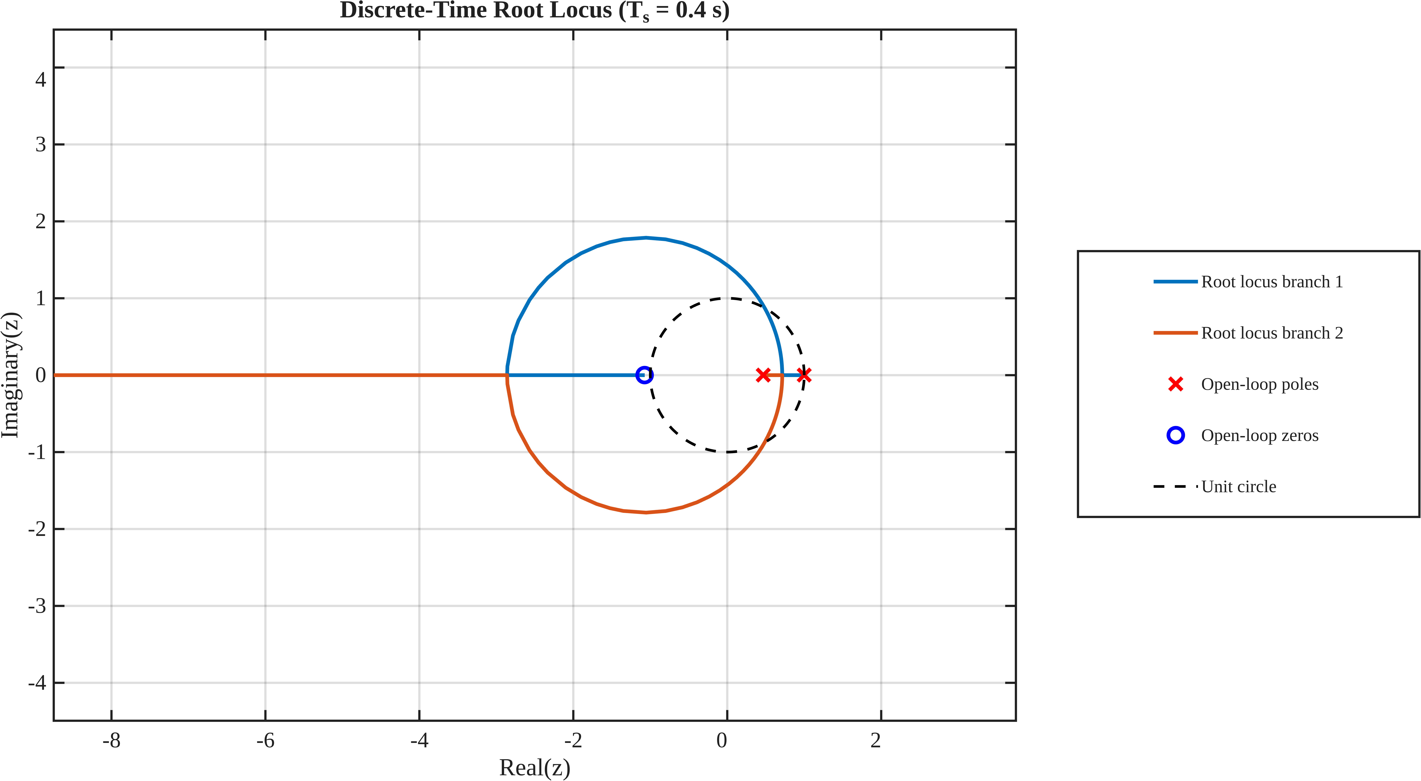

Root Locus for 𝑻 = 𝟎. 𝟓 𝒔
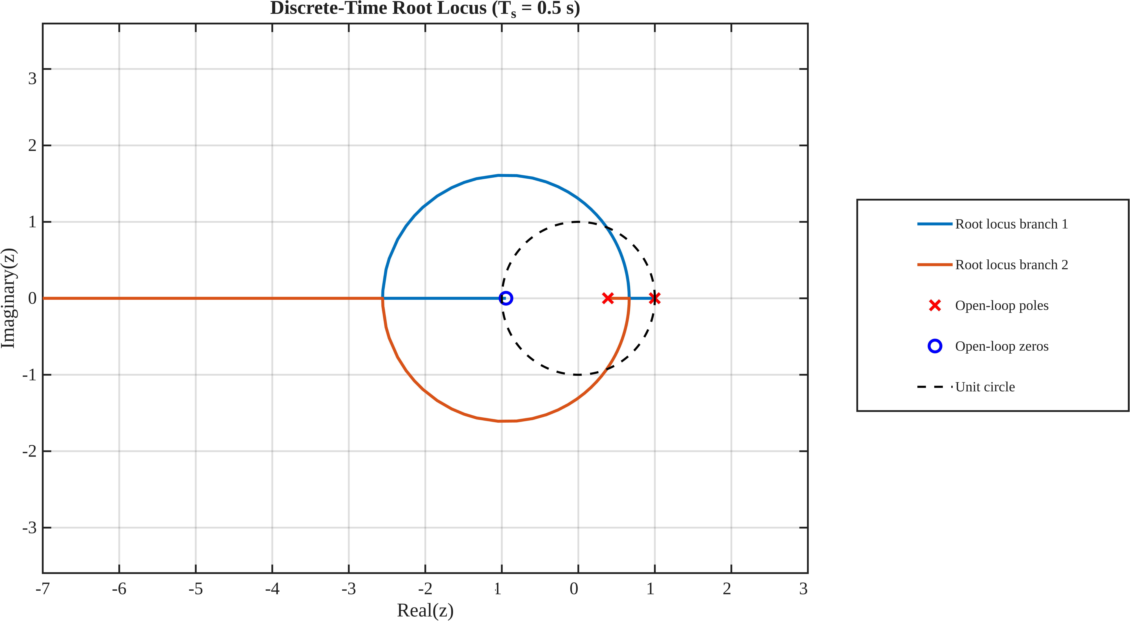

Root Locus for 𝑻 = 𝟎. 𝟔 𝒔
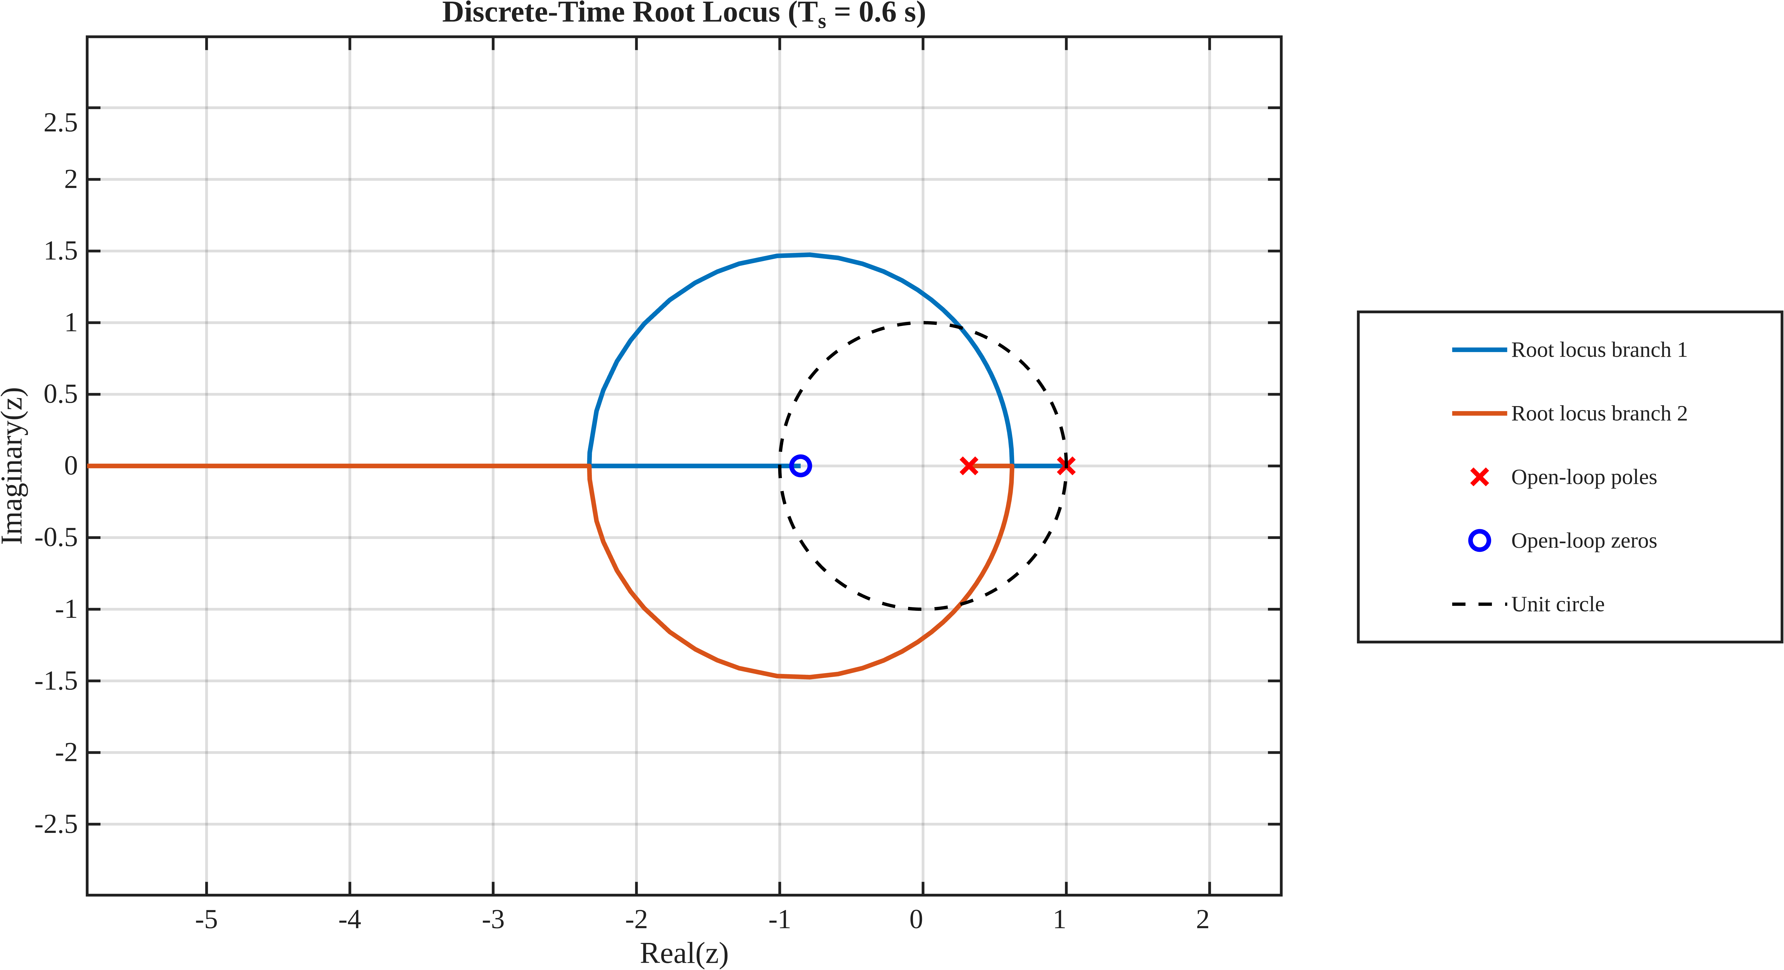

Root Locus for 𝑻 = 𝟎. 𝟕 𝒔

Root Locus for 𝑻 = 𝟎. 𝟖

Root Locus for 𝑻 = 𝟎. 𝟗 𝒔

Root Locus for 𝑻 = 𝟏. 𝟎 𝒔

PROPORTIONAL CONTROLLER DESIGN

For every sampling time, the proportional gain is varied over a specified range. For each value of 𝐾𝑝, the closed-loop transfer function is calculated as
𝐾𝑝𝐺(𝑧, 𝑇)
𝑇(𝑧) = .
1 + 𝐾 𝐺(𝑧, 𝑇)
𝑝

The step response of each closed-loop system is then evaluated. The MATLAB stepinfo function provides:
- settling time 𝑇𝑠
- peak overshoot 𝑀𝑝

A gain is considered acceptable only when
𝑀𝑝≤5%

and

𝑇𝑠≤9𝑠

Thus, for every sampling time,
𝐾𝑝,min(𝑇)≤𝐾𝑝≤𝐾𝑝,max(𝑇)

CONTROLLER-GAIN RESULTS

The calculated controller-gain ranges are:

Ts_{s} | K_{p,min} | K_{p,max}
0.1 | 0.571 | 1.401
0.2 | 0.561 | 1.291
0.3 | 0.561 | 1.191
0.4 | 0.551 | 1.111
0.5 | 0.531 | 1.041
0.6 | 0.511 | 0.971
0.7 | 0.531 | 0.921
0.8 | 0.501 | 0.861
0.9 | 0.481 | 0.831
1 | 0.471 | 0.781

The corresponding detailed performance values are:

T(s) | K_{p,min} | Ts(s) | M_{p}(%) | K_{p,max} | Ts(s) | M_{p}(%)
0.1 | 0.571 | 9 | 0 | 1.401 | 4.8 | 4.961469492
0.2 | 0.561 | 9 | 0 | 1.291 | 5 | 4.996101951
0.3 | 0.561 | 8.7 | 0 | 1.191 | 5.4 | 4.901503729
0.4 | 0.551 | 8.8 | 0 | 1.111 | 5.6 | 4.98111282
0.5 | 0.531 | 9 | 0 | 1.041 | 6 | 4.996582405
0.6 | 0.511 | 9 | 0 | 0.971 | 6 | 4.857184616
0.7 | 0.531 | 8.4 | 0 | 0.921 | 6.3 | 4.842547992
0.8 | 0.501 | 8.8 | 0 | 0.861 | 7.2 | 4.765885547
0.9 | 0.481 | 9 | 0 | 0.831 | 7.2 | 4.965773314
1 | 0.471 | 9 | 0 | 0.781 | 7 | 4.883692224

For sampling time, T = 0.1 s,0.5s,1s
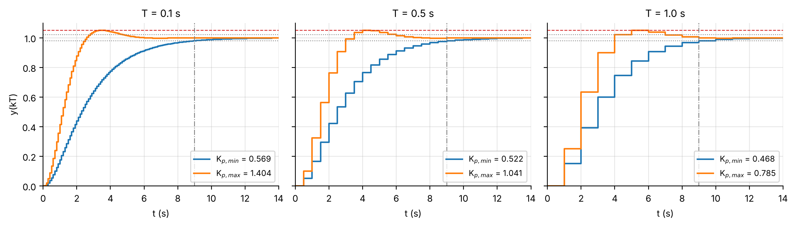

ANALYSIS OF THE CONTROLLER-GAIN RESULTS

The results show that the specified performance requirements can be satisfied for every sampling time considered.
At 𝑇 = 0.1 𝑠, the acceptable gain range is

0.571 ≤ 𝐾𝑝 ≤ 1.401

At 𝑇 = 1.0 𝑠, the acceptable range becomes

0.471≤ 𝐾𝑝 ≤ 0.781

Thus, the permissible proportional-gain range becomes narrower as the sampling time increases.
The width of the allowable gain region is

Δ𝐾𝑝 = 𝐾𝑝,max − 𝐾𝑝,min.

For 𝑇 = 0.1 𝑠,

Δ𝐾𝑝 = 0.830,

whereas for 𝑇 = 1.0 𝑠,

Δ𝐾𝑝 = 0.310.
Therefore, the available controller-gain margin is considerably smaller at the larger sampling time.

SETTLING-TIME ANALYSIS

The settling-time results show that increasing 𝐾𝑝 generally improves the speed of the response. For the minimum acceptable gains, the settling time is approximately at the specified limit of 9 𝑠. At the maximum acceptable gains, the settling time remains below 9 𝑠.
For example,

𝑇 = 0.1 𝑠, 𝑇𝑠 = 4.8 𝑠
at the maximum permissible gain, whereas

𝑇 = 1.0 𝑠, 𝑇𝑠 = 7.0 𝑠.
Thus, the maximum-gain response becomes relatively slower as the sampling time increases.

The graph shows an overall decrease in both the minimum and maximum acceptable proportional gains as the sampling time increases.

The maximum permissible gain decreases from

0.830

at 𝑇 = 0.1 𝑠 to

0.310

at 𝑇 = 1.0 𝑠.

The minimum permissible gain decreases from

0.571

to

0.471.

The upper gain boundary therefore changes more significantly than the lower boundary, resulting in a progressively narrower acceptable controller-gain region.

OVERSHOOT ANALYSIS

Peak overshoot versus proportional gain The overshoot increases with increasing proportional gain.

The maximum permissible gains are selected close to the 5%overshoot limit. For example,
𝑀𝑝 = 4.961469492%

at 𝑇 = 0.1 𝑠, while

𝑀𝑝 = 4.88369922%

at 𝑇 = 1.0 𝑠.

All these values remain below the specified limit:

𝑀𝑝 ≤ 5%.

The overshoot at the maximum permissible gain remains close to the 5%limit throughout the sampling-time range.
At the minimum permissible gain, the overshoot is 0% for all the considered sampling times.

WATERFALL ANALYSIS AT T = 1 S
Seventy closed-loop step responses were generated for K_{p} from 0.1·K_{p,min} to 1.35·K_{p,stab} (csv_user_plant/waterfall_*.csv). Figure 6 (left) stacks them; the right panel plots the resulting overshoot and settling time against K_{p}.
Figure 6. Left: waterfall of step responses at T = 1 s (clipped at y = 2.2). Right: overshoot and settling time against K_{p}; shaded: admissible window; dashed: stability limit.
The picture shows three regimes. Below K_{p,min} the response is overdamped and slow (t_{s} > 9 s). Inside the window t_{s} is not monotone: it falls from 9 s at 0.468 to a minimum of 5 s near K_{p} ≈ 0.63–0.68 (overshoot ≈ 1.4–1.6 %), then rises again to 7 s at K_{p,max} as the oscillation starts to ring across the 2 % band. Above K_{p,max} overshoot grows steeply and t_{s} becomes irregular (the staircase in the right panel is the 2 % band being re-crossed by successive peaks) until the loop reaches sustained oscillation at K_{p,stab} = 4.284. The decay rate σ and damped frequency of the ringing agree with the closed-form pole location (Table 6), confirming the z-plane picture; the gap near K_{p,stab} is the coarse sample grid (about four samples per cycle).

Gain | K_{p} | σ theory (1/s) | σ from simulation | ω_{d} theory (rad/s) | ω_{d} from simulation
Kp,max | 0.785 | 0.593 | 0.601 | 0.622 | 0.634
2.0 | 2.000 | 0.302 | 0.312 | 1.219 | 1.273
3.0 | 3.000 | 0.147 | 0.149 | 1.461 | 1.605
0.95 Kp,stab | 4.070 | 0.022 | 0.047 | 1.649 | 1.723
Pole-based prediction against measured ringing in the simulated step responses (T = 1 s).

EXTENDED HEAT MAPS: THE COMPLETE (T, K_{p}) ANALYSIS
The earlier maps covered only the tested range. Here every quantity of the analysis is evaluated over a much wider plane — T from 0.05 s to 6 s and K_{p} from 0.05 to 100, covering the overdamped region, the whole feasible window, the oscillatory region and the instability boundary — on a 130 × 190 grid, each point from a full discrete simulation (csv_user_plant/combo_heatmap_grid.csv). Figures 7 and 8 show eight quantities on identical axes; in every panel the white contour is OS = 5 %, the cyan contour is t_{s} = 9 s, the dashed line is the stability limit K_{p,stab}(T) and the dotted verticals bound the tested range T = 0.1–1.0 s.
Figure 7. (a) overshoot, (b) 2 % settling time, (c) effective damping ζ_{eff} and (d) decay rate σ of the dominant pole over the (T, K_{p}) plane (log axes). Unstable points are left blank.
(e) overshoot sensitivity dOS/d ln K_{p}, (f) gain margin, (g) phase margin and (h) samples per oscillation 2π/(ω_{d}T). The oblique stripes in (e) and the ragged t_{s} contour at high gain come from the sampled oscillation peaks changing sample.
Reading the maps. (a, c) Overshoot is zero while the poles are real (below breakaway, ζ_{eff} = 1) and rises along bands of falling ζ_{eff}; the 5 % contour is the ζ_{eff} = 0.69 line, and both fall with T. (b, d) Settling time is shortest in a thin strip just above breakaway where σ is largest (≈ 0.7–0.9 s⁻¹) and grows on both sides: below it because the slow pole barely leaves z = 1 (σ → 0 as K_{p} → 0), above it because the complex pair approaches the unit circle. (e) The overshoot sensitivity is essentially zero up to breakaway and then jumps to 16–25 percentage points per unit ln K_{p} at the 5 % edge — the edge sits on this steep slope. (f, g) Margins are monotone in K_{p}: at the 5 % contour the gain margin is 15–23 dB and the phase margin ≈ 62° at every T. (h) At the 5 % contour the ringing spans about 68 samples per cycle at T = 0.1 s but only 10 at T = 1 s, and about 4 near the stability limit, which is the clearest picture of why coarse sampling erodes the design.
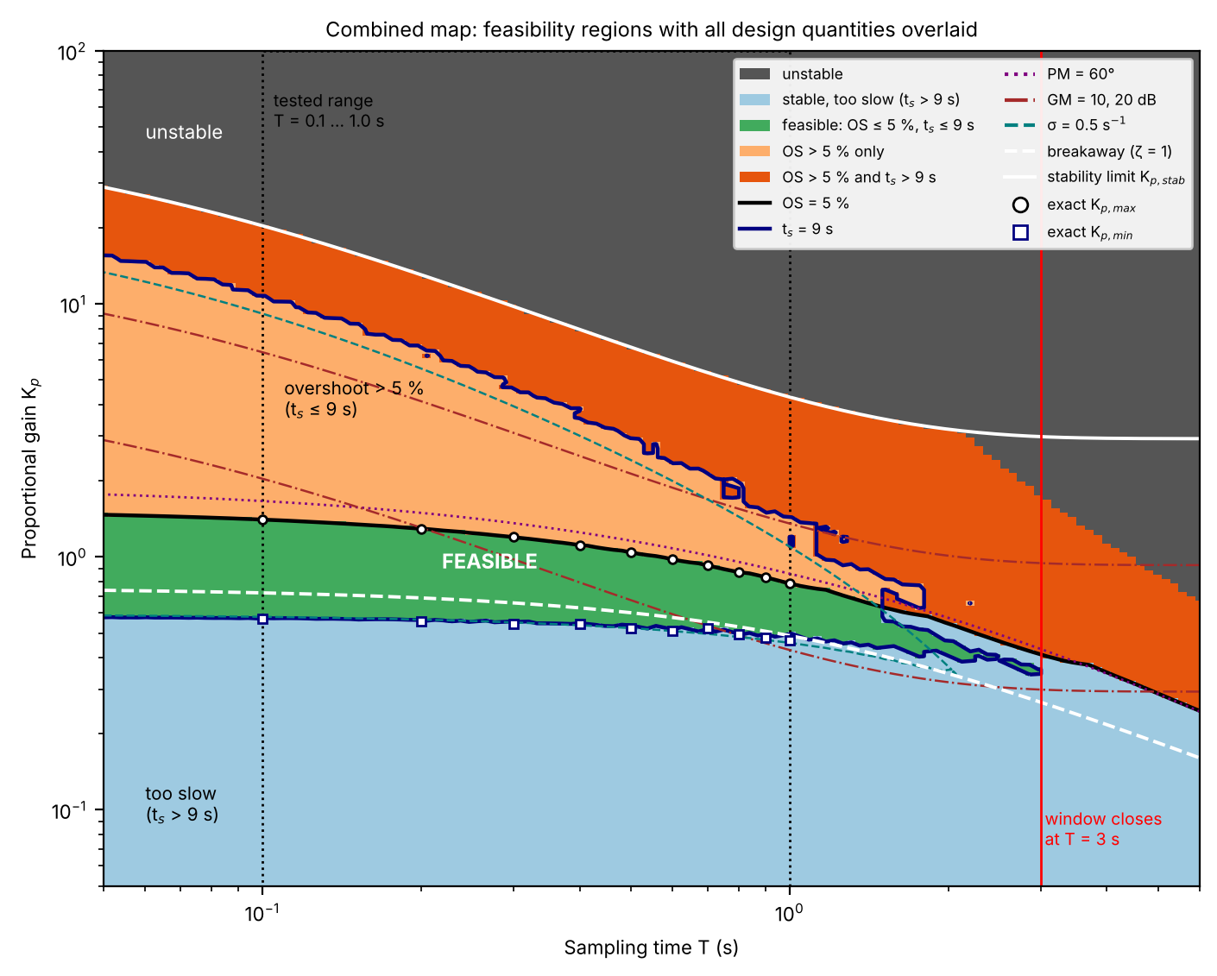
Combined map. Colour: regime (grey unstable; light blue stable but t_{s} > 9 s; green feasible; orange OS > 5 % only; red-orange both violated). Lines: OS = 5 %, t_{s} = 9 s, PM = 60°, GM = 10 and 20 dB, σ = 0.5 s⁻¹, breakaway and stability limit; markers:
T (s) | K_{p,min} | K_{p,max} | window width | breakaway | K_{p,stab} | zero
1.0 | 0.469 | 0.785 | 0.316 | 0.488 | 4.284 | -0.620
1.2 | 0.466 | 0.729 | 0.264 | 0.452 | 3.886 | -0.542
1.5 | 0.422 | 0.633 | 0.211 | 0.406 | 3.514 | -0.452
2.0 | 0.405 | 0.467 | 0.062 | 0.346 | 3.195 | -0.345
2.5 | 0.385 | 0.405 | 0.021 | 0.301 | 3.052 | -0.274
2.8 | 0.349 | 0.381 | 0.033 | 0.279 | 3.007 | -0.242
2.9 | 0.338 | 0.375 | 0.037 | 0.272 | 2.996 | -0.233
3.0 | 0.328 | 0.367 | 0.039 | 0.266 | 2.986 | -0.224
3.5 | — | — | empty | 0.239 | 2.956 | -0.188
4.0 | — | — | empty | 0.217 | 2.943 | -0.162
6.0 | — | — | empty | 0.160 | 2.933 | -0.103
The gain window beyond the tested range (csv_user_plant/extended_window_vs_T.csv; fine scan, step 0.0005).
What the combined map adds.
(i) The feasible band is one connected region over the whole tested range and keeps narrowing beyond it — 0.316 at T = 1 s, 0.264 at 1.2 s, 0.211 at 1.5 s, 0.062 at 2 s, 0.021 at 2.5 s .
(ii) It closes completely at T = 3 s: since t_{s} can only be a multiple of T, the 9 s limit corresponds to three samples at T = 3 s, a narrow window (0.328–0.367) remains, and for T > 3 s fewer than three samples are allowed and no gain satisfies both specifications, even though the loop is still stable up to K_{p} ≈ 3.
(iii) Above the green band the overshoot violation is the only failure over a wide gain range (orange), and the gap to instability (grey) is a factor 5–15 at the tested T; below breakaway the failure is always settling time (light blue), never overshoot.
(iv) The contour of σ = 0.5 s⁻¹ runs along the lower edge of the window for T ≲ 1 s, confirming that the lower edge is the slow-pole condition of §10, while the PM = 60° line lies just above the 5 % contour (PM ≈ 62° at its edge) and the GM = 10 dB line lies 1.7–4.6× higher in gain, so the overshoot edge is also the edge of a comfortable phase margin.
(v) The non-minimum-phase zero (T < 0.453 s) leaves no visible mark on the maps: at fine sampling the design is governed by the same two edges.

FREQUENCY-DOMAIN CHECKS

T (s) | GM at K_{p,max} (dB) | PM at K_{p,max} (°) | GM at K_{p,min} (dB) | PM at K_{p,min} (°) | ω_{b} (rad/s) | π/T (rad/s) | (π/T)/ω_{b}
0.1 | 23.2 | 63.7 | 31.1 | 78.2 | 1.302 | 31.42 | 24.1
0.2 | 20.1 | 63.3 | 27.4 | 77.5 | 1.239 | 15.71 | 12.7
0.3 | 18.2 | 63.0 | 25.1 | 76.8 | 1.184 | 10.47 | 8.8
0.4 | 17.1 | 62.8 | 23.3 | 75.9 | 1.124 | 7.85 | 7.0
0.5 | 16.2 | 62.6 | 22.2 | 75.5 | 1.073 | 6.28 | 5.9
0.6 | 15.7 | 62.5 | 21.3 | 75.0 | 1.023 | 5.24 | 5.1
0.7 | 15.2 | 62.3 | 20.2 | 73.8 | 0.984 | 4.49 | 4.6
0.8 | 15.0 | 62.4 | 19.9 | 73.7 | 0.935 | 3.93 | 4.2
0.9 | 14.8 | 62.2 | 19.6 | 73.4 | 0.902 | 3.49 | 3.9
1.0 | 14.7 | 62.3 | 19.2 | 73.0 | 0.856 | 3.14 | 3.7
Gain/phase margins at both edges and closed-loop −3 dB bandwidth at K_{p,max} (csv_user_plant/B1_margins.csv, C1_bandwidth.csv).
Gain margin and phase margin at both edges against T, and the Nyquist plot at T = 1 s for K_{p,max}, a mid gain and K_{p,stab} (the last passes through −1; no encirclements for the first two).
The phase margin at K_{p,max} is almost independent of T (62–64°, the 5 % overshoot signature) while at K_{p,min} it is 73–78°; the gain margin falls from 23 dB to 14.7 dB (T = 0.1 → 1 s) at K_{p,max} and equals 20 log10(Kp,stab/Kp) by construction. At T = 1 s the Nyquist curve for K_{p,max} stays 0.69 from −1 with no encirclement, while the K_{p,stab} curve touches −1. The closed-loop bandwidth falls from 1.30 to 0.86 rad/s, whereas the Nyquist frequency π/T falls from 31 to 3.1 rad/s: the ratio drops from 24 to 3.7, so at T = 1 s the loop is sampled only about 3.7× faster than its bandwidth — far short of the usual 10–20×, which is why the digital limits differ so much from the analog ones at this T.

DISCUSSION

The experimental results demonstrate the influence of sampling time on the design of a digital proportional controller.
Although the same continuous-time plant is used as the basis of the analysis, its discrete representation changes with the sampling interval according to
𝑧 = 𝑒^{𝑠𝑇}.

Consequently, changing the sampling time changes the discrete poles and zeros and therefore modifies the root-locus trajectory.
The controller gain must consequently be selected according to the corresponding sampling time.
The results show that the maximum permissible gain decreases considerably as the sampling time increases. This causes the acceptable range of controller gains to become progressively narrower.
The transient-response results also demonstrate the trade-off between controller gain, settling time and overshoot. Increasing 𝐾𝑝generally produces a faster response, but also moves the system closer to the overshoot constraint.
The two performance requirements therefore establish the boundaries of the permissible controller-gain region:
𝑇𝑠 ≤ 9 𝑠
determines the lower gain requirement, while

𝑀𝑝 ≤ 5%

limits the upper gain.

An acceptable proportional-gain range was obtained for every sampling time from 0.1s to 1.0s. The minimum permissible gain is mainly governed by the settling-time requirement of Ts ≤ 9s, since gains below this value result in a response that is too slow. On the other hand, the maximum permissible gain is mainly governed by the peak-overshoot requirement of Mp ≤ 5%, since increasing the gain generally produces a faster but more oscillatory response. Thus, the settling-time requirement establishes the lower boundary of the permissible gain range, while the overshoot requirement establishes the upper boundary.
The maximum permissible proportional gain decreases significantly as the sampling time increases. It decreases from 1.401s at T=0.1s to 0.921074 at T=0.781s. This occurs because increasing the sampling time changes the mapping of the continuous-time system into the discrete domain, thereby changing the pole-zero configuration and the corresponding root-locus trajectory. For the plant considered, this causes the overshoot constraint to be reached at a progressively lower proportional gain.
Consequently, the acceptable range of proportional controller gains becomes narrower as the sampling time increases. The reduction is particularly noticeable in the upper gain boundary, which decreases more significantly than the lower boundary. Therefore, larger sampling intervals provide a smaller range of controller gains capable of satisfying both the settling-time and overshoot specifications. Overall, the observations confirm that the sampling time has a significant effect on the discrete controller design and must be considered when selecting the proportional controller gain.
The apparently extreme analog 𝑲𝒑values are not because the analog calculation is wrong. They differ from the 𝑻 = 𝟏 𝒔 digital values because 𝑻 = 𝟏 𝒔 is a relatively large sampling interval. As the sampling time decreases, the discrete 𝑲𝒑limits converge toward the continuous-time values. Hence, the analog result should be compared primarily with the 𝑻 = 𝟎. 𝟏 𝒔 case, not the 𝑻 = 𝟏 𝒔 case.

OBSERVATIONS

- The damping ratio corresponding to 5%peak overshoot is
    - .
𝜁=0.6901
- The digital transfer function changes for every sampling time.
- The discrete root locus therefore changes with sampling time.
- An acceptable proportional gain range exists for all sampling times from 0.1 𝑠 to 1.0 𝑠.
- The minimum permissible gain is mainly governed by the settling-time requirement.
- The maximum permissible gain is mainly governed by the overshoot requirement.
- The overshoot at the minimum gain is 0%for all sampling times.
- The overshoot at the maximum gain remains close to 5%.
- The maximum permissible gain decreases significantly with increasing sampling time.
- The acceptable gain range becomes narrower as the sampling time increases.

CONCLUSION

The proportional controller design was successfully carried out using discrete root-locus analysis for sampling times ranging from 0.1 𝑠to 1.0 𝑠.
For every sampling time, the digital plant was obtained using zero-order-hold discretization and the proportional gain was varied to determine the range satisfying
𝑀𝑝 ≤ 5%

and

𝑇𝑠 ≤ 9 𝑠.
The results demonstrate that the sampling time has a significant influence on the digital controller design.
The permissible gain range changes from
0.571≤𝐾𝑝≤1.401

at 𝑇 = 0.1s to
0.471≤𝐾𝑝≤0.781

at 𝑇 = 1.0 𝑠.

Hence, increasing the sampling time generally reduces the allowable proportional gain range. The experiment therefore demonstrates the importance of considering sampling time when designing and interpreting a digital root-locus controller.how do i capitalize text in only office

